Assignment [String and List]

1. Write a program to find the sum of all elements of a list.

ANS:  
lst = [int(item) for item in input("Enter the list items with space separated : ").split()]

print("Sum of all elements is: ",sum(lst))

o/p



1. Write a program to find the maximum and minimum element of a list.

ANS:

lst = [int(item) for item in input("Enter the list items with space separated : ").split()]

print("Maximum element in the list is: ",max(lst),"\nMinimum of the list is: ",min(lst))

o/p

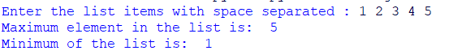

3. Write a program to find the position of maximum and minimum element’s position in a

list.

ANS:

lst = [int(item) for item in input("Enter the list items with space separated : ").split()]

mx,mi=max(lst),min(lst)

print("Maximum element in the list is: ",lst.index(mx),"\nMinimum of the list is: ",lst.index(mi))

o/p

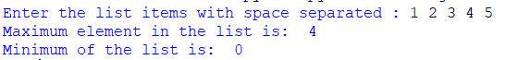

1. Write a program to print all the element in a list that are greater than a given value.

ANS:

lst = [int(item) for item in input("Enter the list items with space separated : ").split()]

vl=int(input("Enter a value: "))

for ele in lst:

if ele>vl:

print(ele," is greater than ",vl)

o/p

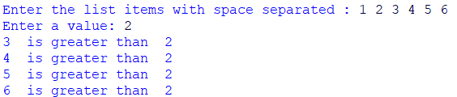

5. Write a program to print all the common elements of 2 list.

6. Write a program to reverse a list.

7. Write a program to find the second largest and second smallest value from a list.

8. Write a program to find the average of all elements in a list.

9. Write a program to to generate random numbers within a given range and store it in a list.

10. Write a program to split the even and odd elements into 2 different lists.

12. Write a Python script that takes input from the user and displays that input back in upper and lower cases.

13. Write a Python program to count and display each of the vowels of a given text.

14. Write a Python program to remove spaces from a given string.

15. Write a Python program to capitalize first and last letters of each word of a given string.